**Madan Bhandari Memorial College**

Affiliated to Tribhuvan University

Baneshwor, Kathmandu



**Project Proposal on**

**Restaurant Management System**

**Under the supervision of**

**Ram Kumar Basnet**

**Submitted By**

Utshav Poudel

Nischal Kunwar

Aayush Basnet

**Submitted To**

Department of Computer Science and Information Technology

Madan Bhandari Memorial College

Baneshwor, Kathmandu

**Abstract**

The "Restaurant Management System" is a software solution aimed at simplifying restaurant operations. It enables efficient order tracking, status updates, with a centralized dashboard for real-time monitoring and dynamic menu management, the system minimizes errors and improves operational efficiency.

**Introduction**

Managing customer orders efficiently is a significant challenge for restaurants, especially during busy hours. Errors in order tracking and delays in updates can lead to poor customer experiences. To address this, our project, "Restaurant Management System," aims to simplify the process of managing orders and menus in restaurants.

**Objective**

1. Simply ordering through table tablets.
2. Track and provide real-time updates on order status.
3. Enhance operational efficiency and reduce manual errors.

**Overview**

The Restaurant Management System integrates a web-based interface with backend support to manage restaurant operations seamlessly. The system consists of the following modules:

1. Login Page: Secure user authentication to access the dashboard.
2. Dashboard: Centralized management area where orders and menus can be monitored and updated.
3. Order Management: Module to handle incoming orders, update statuses, and notify kitchen staff.
4. Menu Management: Module to add, update, or remove menu items dynamically.

**Workflow Diagram**

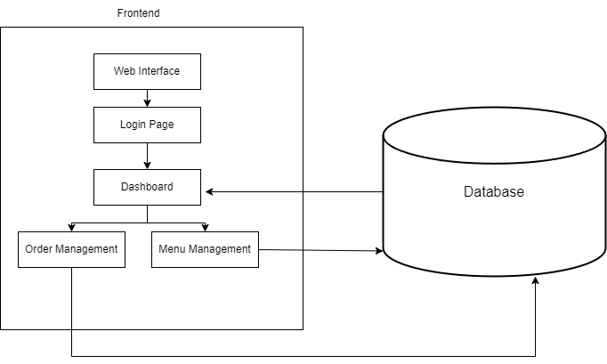

**Steps/Description:**

1. Web Interface:
   * The entry point for restaurant or hostel staff to access the application.
   * Allows login credentials to be entered.
2. Login Page:
   * Verifies user credentials for secure access to the dashboard.
3. Dashboard:
   * A centralized interface providing real-time analytics and insights.
   * Displays charts and performance data, including top orders, busiest times, and sales metrics.
4. Order Management:
   * Handles the creation, tracking, and updating of customer orders.
   * Notifies staff about pending or completed orders.
5. Menu Management:
   * Allows restaurant or hostel staff to add, edit, or remove menu items easily.
   * Updates are reflected instantly for the staff.
6. Database:
   * Stores data such as user credentials, orders, menus, and analytics.
   * Ensures real-time synchronization across all modules.

**Verification**

1. Login functionality will verify user access for restaurant and hostel staff.
2. Menu management ensures accurate and dynamic menu updates.
3. Order management tracks and updates each order's progress efficiently.
4. The dashboard provides detailed analytics, allowing verification of business performance, including top-selling items, busiest hours, and sales figures.
5. Real-time data synchronization between the database and modules ensures consistency and accuracy in reporting.